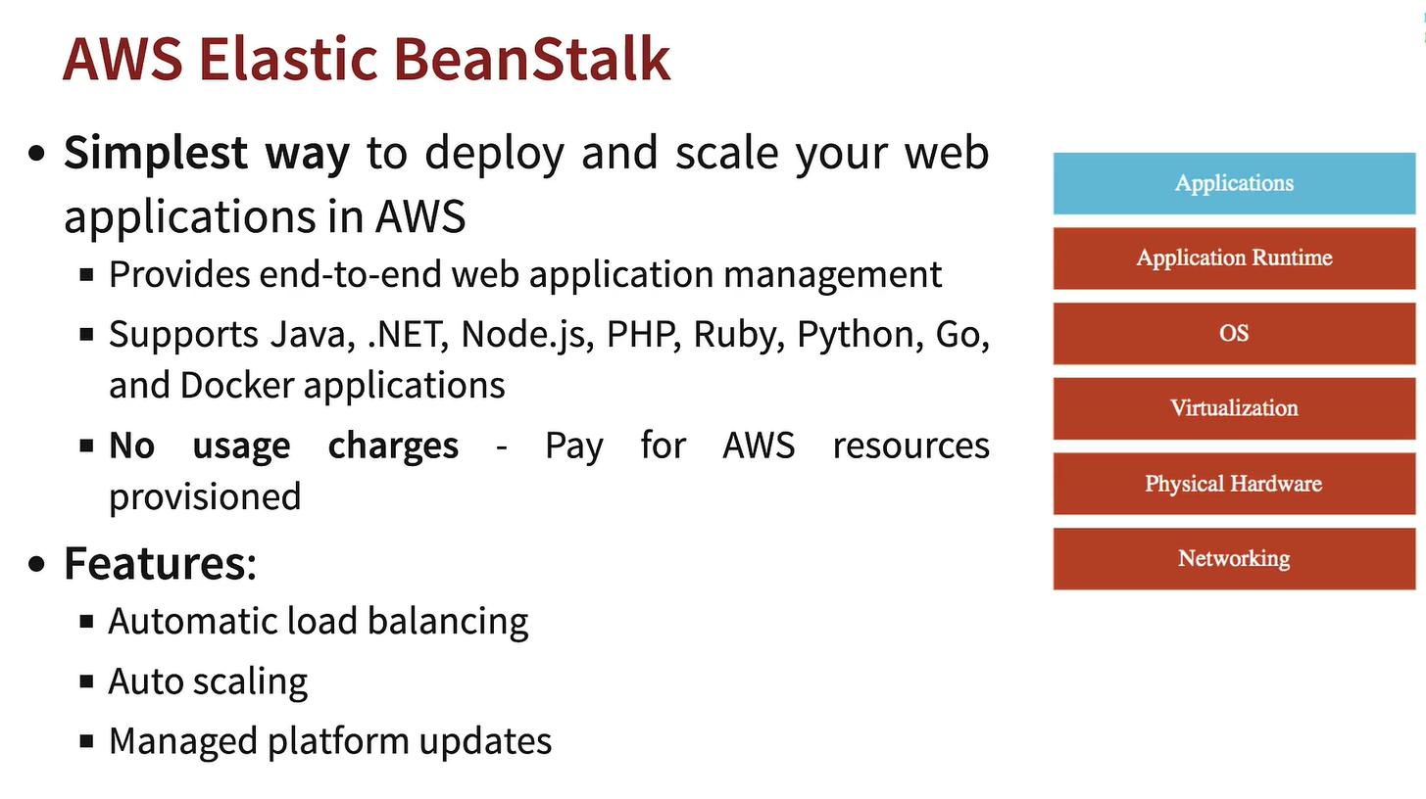
Elastic Beanstalk itself is free. Then how are we billed?
You are billed for the AWS resources (EC2, Load Balancer, RDS, S3, CloudWatch, etc.) that Elastic Beanstalk creates and manages on your behalf.
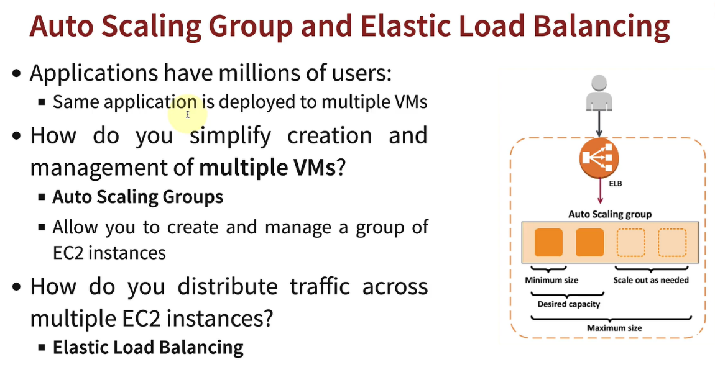

This is required if using EC2,
Else in beanstalk, it is all auto handled.
Agar Elastic Beanstalk use nahi karte (EC2/IaaS approach):
Tumhe manually setup karna padta:
EC2 instances
↓
Security Groups
↓
Application deployment (git pull code and then build the application in EC2 console)
↓
Elastic Load Balancer (ALB/NLB)
↓
Auto Scaling Group (ASG)
↓
Scaling policies (CPU > 70%, etc.)
↓
Health checks
↓
Rolling deployments
↓
Monitoring and updates

But AWS Elastic Beanstalk use karte ho:
Tum mainly ye batate ho:
Application code
↓
Platform (Node.js, Java, Python, etc.)
↓
Environment configuration
Aur bss fir, Beanstalk automatically: AWS ki existing services use karta hai:
✓ EC2 instances provision karta hai
✓ Auto Scaling Group create karta hai
✓ Load Balancer configure karta hai
✓ Health monitoring setup karta hai
✓ Deployments manage karta hai
✓ Rolling updates support karta hai
✓ CloudWatch integration provide karta hai

WHY DOCKER COMES ?????
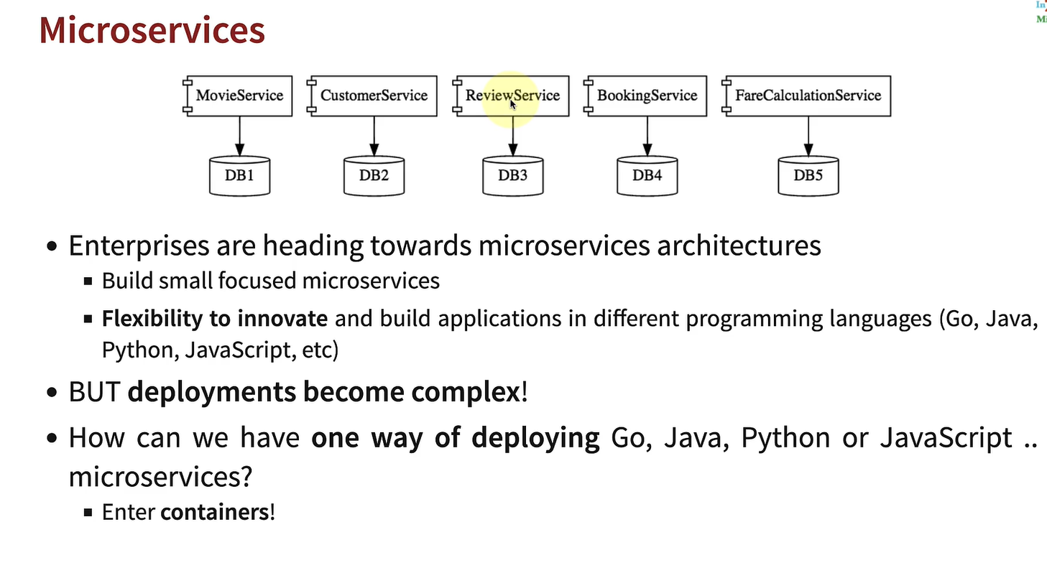
Example: Microservcies like this:
User Service → Java
Payment Service → Node.js
Recommendation Service → Python
Notification Service → Go
Architecture:
API Gateway
├── User Service (Java)
├── Payment Service (Node)
├── Recommendation (Python)
└── Notification (Go)
Ab problem kya hui? Sabka deployment alag krna pdta tha. Becoz of Different languages, Different runtimes, Different build tools, Different packaging formats, Different startup commands
Java : mvn package - > app.jar. Deploy JAR.
Node.js : npm install - > npm run build -> node server.js
Python: pip install -> python app.py
Go : go build - > binary
Industry ne problem ka solution kaise nikala? Dockerize everything.
Docker bolta hai: "Mujhe fark nahi padta tum Java ho ya Python. Sabko container mein pack kar do."
Node:
FROM node:20
COPY .
RUN npm install
CMD ["npm", "start"]
↓
Image:payment-service:v1
Java:
FROM openjdk:21
COPY app.jar .
CMD ["java", "-jar", "app.jar"]
↓
Image: user-service:v1
Python:
FROM python:3.12
COPY .
RUN pip install -r requirements.txt
CMD ["python", "app.py"]
↓
Image: recommendation:v1
Ab deployment kaise hota hai?
Kubernetes/ECS ko sirf ye bolte ho: Deploy this image.
Code ->Docker Image (docker build - > docker push ) -> Registry -> Kubernetes/ECS

Small Team (2–5 services)
Elastic Beanstalk
Kaafi common.

Medium Team (10–20 services)
Docker + ECS
Bahut common.

Large Team (50+ services)
Docker + Kubernetes
Almost standard.

Docker is generally used if having more than one service. So that we can make images. And if using Docker images then must use service that can orchestrate images like – ECS or Kubernetes.
For normal projects (one service or one type of language code), we can simply use Beanstalk or EC2(VM) or Vercel etc.
Flow for having more than one Service in Project: GitHub -> CI/CD (GitHub Actions) -> Docker (Packaging) -> ECS / Kubernetes / Beanstalk (Deployment) -> AWS Infrastructure
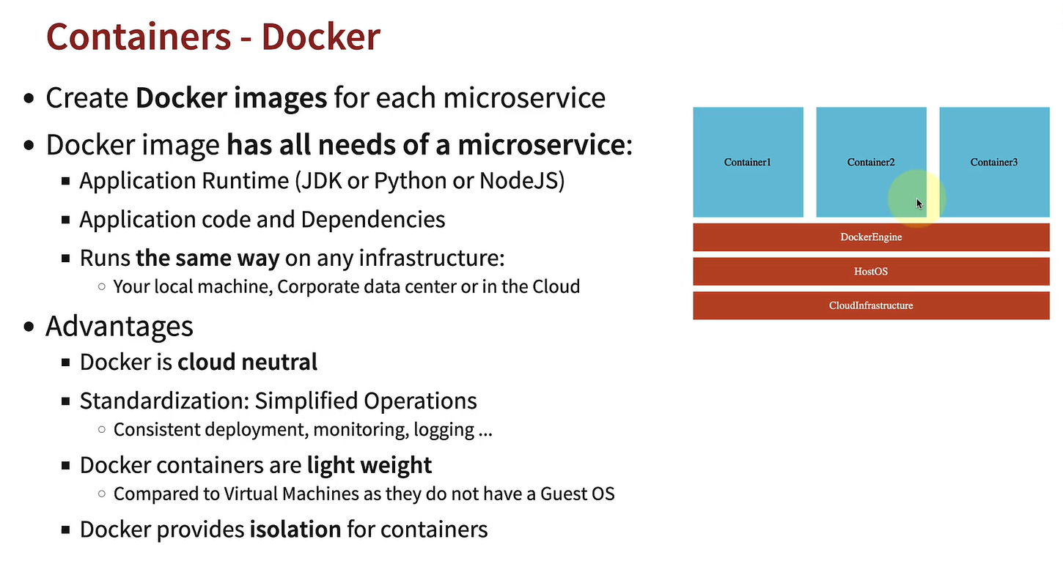
What is Container Orchestrator means: Means something that helps in autoscaling, helps in microservice to talk with each other without need or hardcode url of each service to write in each other code. Helps in load balancing and much more of each docker images. It helps docker images in: Restart kaun karega? Scaling kaun karega? Networking kaun karega? Rolling updates kaun karega?
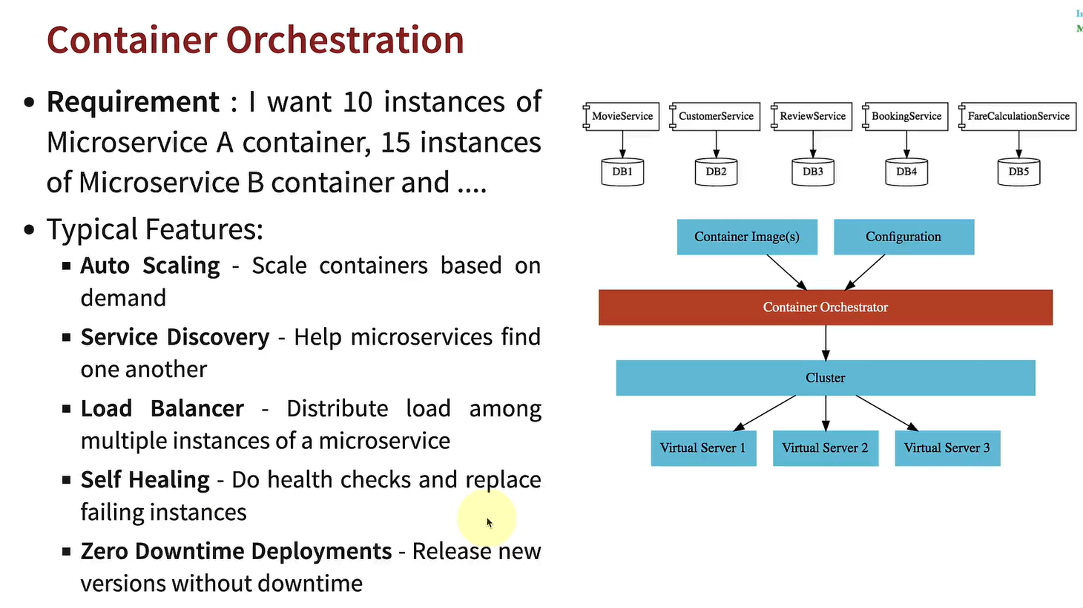
Now some Orchestrator options in AWS.
In EKS and ECS we have to setup: How many ec2 instances to be created and which hardware/OS to be used for the ec2 instances.
But Fargate is serverless means it will handle everything above, just be ready with your configuration.
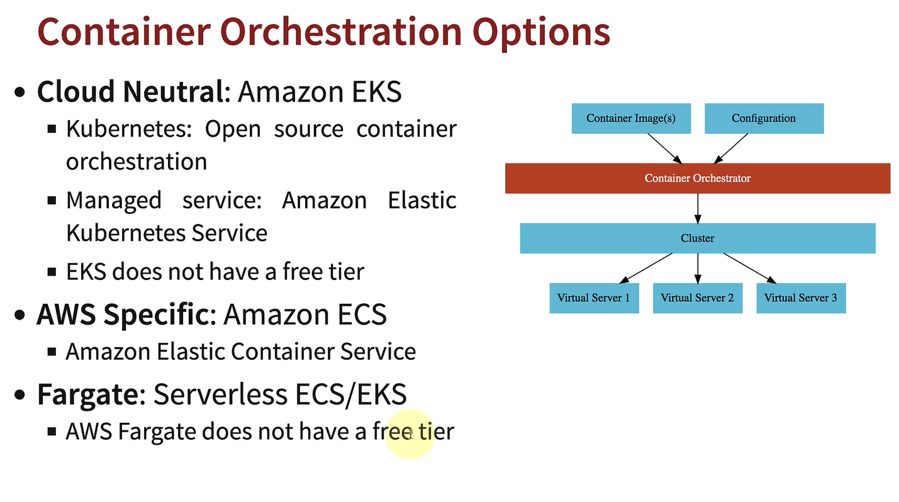

NOW LET’S ANALYSE THE WAY TO DEAL WITH CODE AND MAKE IT LIVE:
Tumhara goal: Code likho -> Production mein chalao - > Users use karein
Bas. Ab is goal ko achieve karne ke alag-alag tareeke hain.
Way 1: EC2 (Manual)
GitHub -> SSH into EC2 -> git pull -> npm install -> npm run build -> pm2 restart
But Problems:
❌ Manual, baar baar build kro and error ho skti
❌ Error-prone
❌ Scaling difficult
Way 2: EC2 + CI/CD
GitHub Push -> GitHub Actions -> SSH into EC2 -> Deploy automatically
Benefits:
✅ Automatic deployment
❌ Still managing servers
Way 3: Elastic Beanstalk
GitHub Push -> GitHub Actions (optional) -> Elastic Beanstalk -> AWS provisions EC2 + ALB + ASG -> App runs
Benefits:
✅ Auto deployments
✅ Auto scaling (ASG)
✅ Load balancing (ALB)
✅ Easier than EC2
Problems:
❌ Less flexibility
❌ Multiple language microservices become awkward, becoz for each language of code, hume baar baar Beanstalk configure krna pdega and banana pdega. Beanstalk help karega, but sab alag-alag platforms honge, toh dealing krna pdega.

Way 4: Docker + ECS/EKS
GitHub Push -> GitHub Actions -> Docker Build -> Push Image to ECS/EKS -> ECS/EKS Deploy
Benefits:
✅ Standardized deployments
✅ Great for microservices
✅ AWS managed orchestration

Now why do we use Monitoring tools? If beanstalk/EKS/ECS gives us all monitoring data
Beanstalk / ECS / EKS / AWS: Ye primarily infrastructure aur platform monitor karte hain.
Example:
EC2 CPU Usage
Memory Usage
Disk Usage
Network Traffic
Container Restart Count
Pod Health
ALB Request Count
ALB 5XX Errors
Auto Scaling Events
Tum dekh paoge:
CPU = 90%
Pod restart hua
Container unhealthy hai
Lekin business level pe? Suppose tumhare paas:
Order Service
Payment Service
Inventory Service
Notification Service
Ab customer bolta hai: "Payment ho rahi hai, but order place nahi ho raha."
AWS ka built-in monitoring bolega:
CPU = 25%
Containers healthy
ALB healthy
Sab green. Lekin problem fir bhi hai.
Yahan Observability tools kaam aate hain Jaise:
Prometheus
Grafana
Datadog
New Relic
Dynatrace
OpenTelemetry
Jaeger
Ye bolte hain:
Payment Service latency = 50ms
Inventory Service latency = 15 seconds ❌
95% requests yahin slow ho rahi hain.

Real World Examples with useCase:
Small startup: Beanstalk + CloudWatch
Medium company: ECS + CloudWatch + Grafana
Large company: EKS + Prometheus + Grafana + OpenTelemetry + Datadog

Now if we have BeanStalk, then why ECS and EKS ??
Beanstalk: useful hai jab tum simplicity chahte ho.
Tum bolte ho:Mera Node app deploy kar do.
AWS: EC2, ALB, ASG, Deployment, Monitoring ---- > sab bana deta hai.
Tum details kam dekhte ho.
ECS: useful hai jab tum Docker-based microservices chahte ho bina Kubernetes ki complexity ke. Aur tum AWS mein hi rehne wale ho.
Tum bolte ho:Ye Docker image hai. 2 tasks chalao. CPU 70% pe scale karo. ALB attach karo.
Tum zyada control dete ho.
EKS: useful hai jab tumhe Kubernetes ecosystem aur enterprise-level flexibility chahiye. 100+ services, Multiple teams, Multi-cloud strategy
Tum bolte ho: Deployment YAML, Service YAML, Ingress YAML, ConfigMaps, Secrets
Tum almost sab decide karte ho.

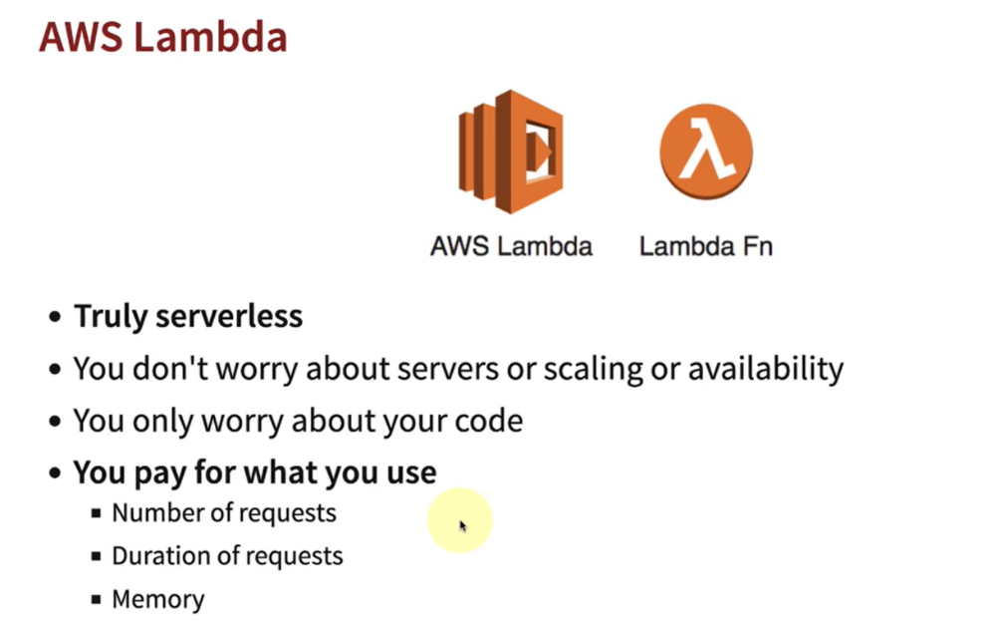
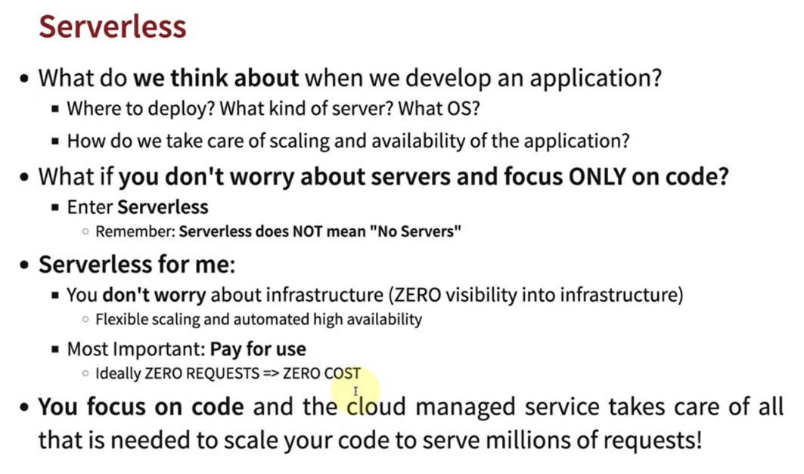

Serverless Doesn’t mean no-server, it just means don’t care about infra, just use it. Mtlb ki cpu, memory and task nhi configure krna pdta (Hence Beanstalk, ECS, EC2, EKS these all are not serverless, becoz they require configuration)
AWS Lambda is truly serverless service in AWS. It used Lambda functions, and we pay for number of req coming via lambda function. Agar tum kisi modern AWS project meho, toh Lambda milne ke chances bahut zyada hain — especially for notifications, cron-jobs, APIs, image processing, integrations, etc. It also auto scales when more req comes.
Lambda kab run hota hai? Only Koi event aane par.
Examples: API Request aayi -> Lambda run
S3 me file upload hui -> Lambda run
Schedule 9 AM hua -> Lambda run
SQS me message aaya -> Lambda run
Ab compare karte hain :
Beanstalk: Tum: Node app deploy karo.
AWS: EC2, ALB, ASG banata hai.
Lekin: Server chal rahe hain 24x7. Chahe traffic ho ya na ho. You have to pay for it.
ECS: Tum: Docker image deploy karo.
AWS:Containers chala deta hai.
Lekin: Tasks chal rahe hain 24x7. You have to pay for it.
EKS: Tum: Kubernetes workloads deploy karo.
Lekin: Pods chal rahe hain 24x7. You have to pay for it.
Lambda: Tum: Function deploy karo.
AWS: Request aayi? -> Function run.
Kaam khatam? -> Function stop. You Don’t pay for it.

